October 19, 2026
INPEX and Sumitomo Osaka Cement Commence Demonstration Testing of Ca-Looping Technology for CO₂ Capture from Large Vessels

TOKYO, JAPAN - INPEX CORPORATION (INPEX) and Sumitomo Osaka Cement Co., Ltd. (SOC) announced today that they have commenced demonstration testing of a technology that captures CO₂ through the repeated use of calcium (Ca) compounds (Ca-Looping technology), which the two companies have been jointly researching since August 2023.

Ca-Looping technology leverages the ability to convert CO₂ into calcium carbonate, which can be transported under ambient temperature and pressure conditions. A demonstration facility has been installed at the National Maritime Research Institute in Mitaka City, Tokyo, where testing is currently underway.

The overall process of Ca-Looping technology is illustrated in Figure 1 and consists of the following steps.
- CO₂ emitted from large vessels and other emission sources is captured using an alkaline solution (NH₄OH).
- The CO₂-containing solution (NH₄HCO₃) is brought into contact with calcium hydroxide (Ca(OH)₂), producing calcium carbonate (CaCO₃).
- The resulting calcium carbonate is transported to a CO₂ storage site, where it is decomposed into CO₂ and calcium oxide (CaO).
- The separated CO₂ is permanently stored underground.
- The calcium oxide is hydrated to regenerate calcium hydroxide (Ca(OH)₂).

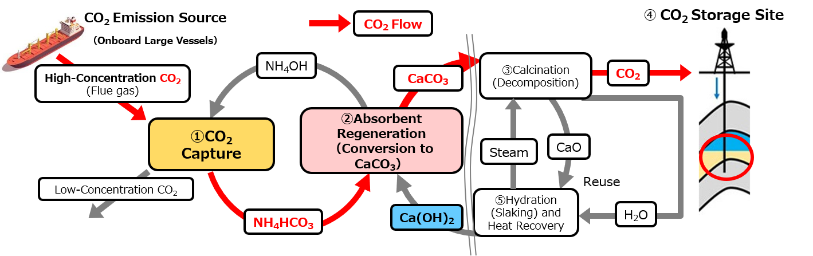

Figure 1. Overall Process of the Ca-Looping Technology

As an initial application, the technology is being developed for installation on large vessels, where international regulations on CO₂ emissions are becoming increasingly stringent. Looking ahead, the companies aim to enable broader deployment of Ca-Looping technology across society, as illustrated in Figure 2. The technology is also expected to contribute to the effective utilization of CO₂ storage sites owned or operated by INPEX in Japan and overseas.

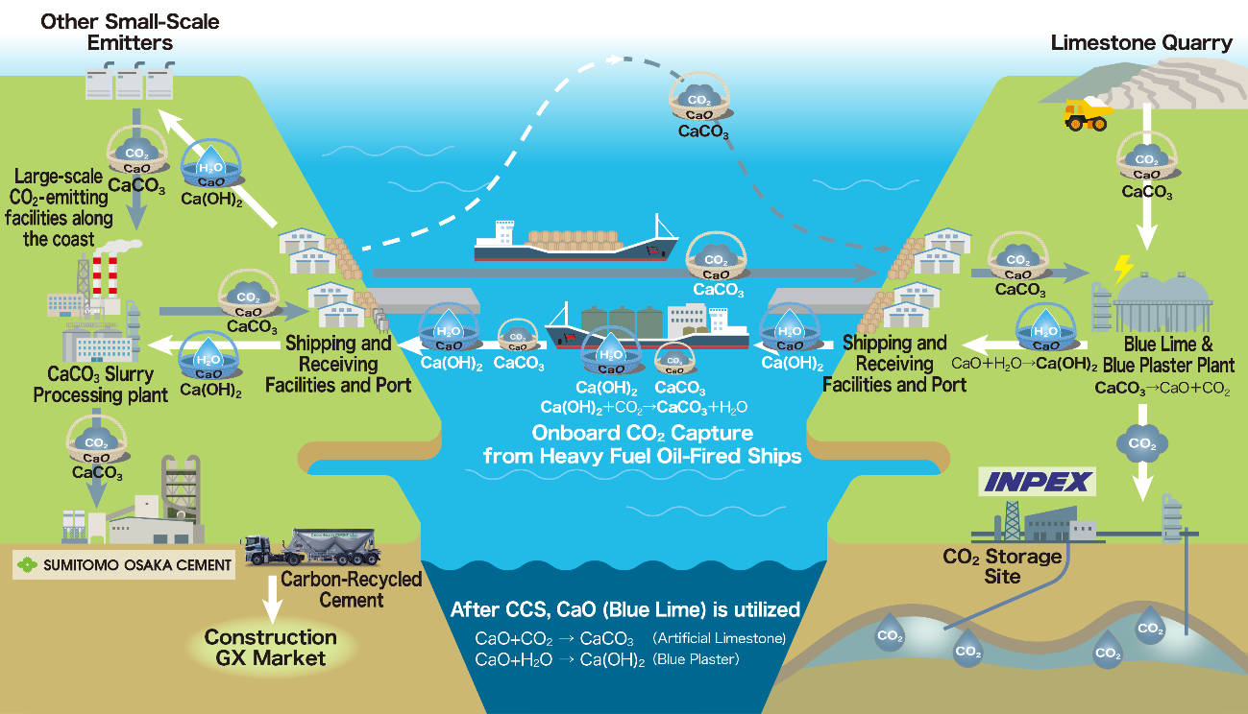

Figure 2. Future Vision for Social Implementation of the Ca-Looping Technology

In INPEX Vision 2035 formulated in February 2025, INPEX positions the acquisition of competitive advantages through research and development as a key objective. By integrating its existing technologies and expertise with new knowledge and capabilities gained through R&D, INPEX aims to further strengthen its existing businesses and create new growth opportunities.

In SOC “2050 Carbon Neutrality Vision ‘SOCN2050’ Version 2.0,” revised in May 2026, SOC has outlined a roadmap that includes achieving carbon neutrality through the production and use of artificial limestone, as well as exploring CCS in collaboration with partners through open innovation. The company aims to leverage the insights gained from this joint initiative to create new carbon-related businesses.

By combining INPEX’s extensive experience in operating CO₂ separation and capture processes and its expertise and portfolio of geological storage sites in Japan and overseas with SOC’s carbon mineralization-based CCU technologies, the two companies will advance technological development necessary for realizing a decarbonized society through open innovation and knowledge sharing.

Media Contact

INPEX: Public Relations Group, Tel) +81-3-5572-0750

SOC: Corporate Planning Department, Tel) +81-3-6370-2725

